# Services offered by Brilliant engineering

**Industrial Electrical Service.**

Brilliant engineering has qualified artisans with vast experience in industrial machine installations, commissioning, safety inspections, repairs and maintenance**.** We have experience in DC and AC Variable frequency drives (VFDs), Programmable logic controllers (PLCs), machine installations and motor circuits design & installations. We offer breakdown maintenance in which we promise our clients a quick response rate and timeous execution hence improving their Overall Equipment Efficiency (OEE).

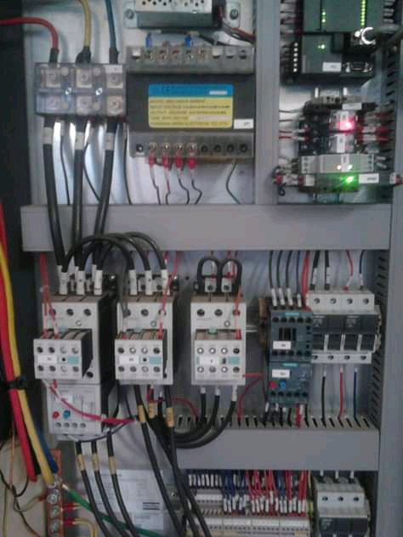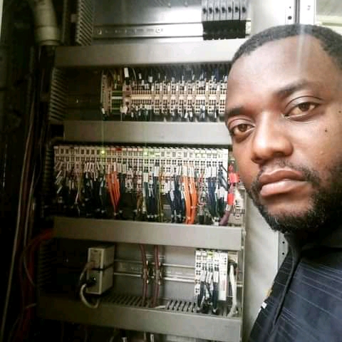

**Solar system installations.**

Going green is good for both the pocket and the environment. By investing in a solar system companies and individuals will reduce their electricity bills thereby reducing energy demand on the national grid. This will hence mean a reduction in the demand of non-renewable resources therefore less carbon will be emitted into the atmosphere thereby protecting the ozone layer. We do solar system installations ranging from small domestic systems to large commercial systems. In all our installations we guarantee you quality workmanship and a commitment to follow safety procedures and standards. We will never compromise on quality and safety for anything

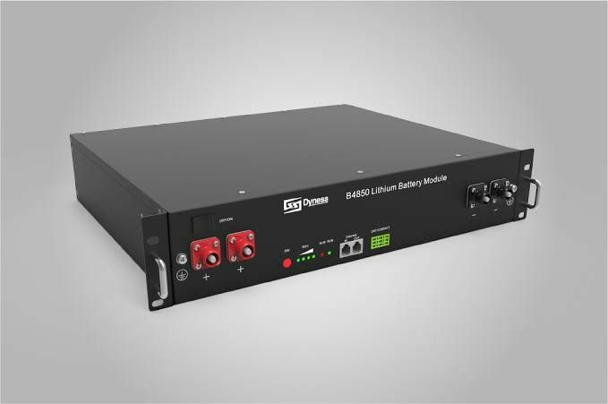

LITHIUM BATTERY MODULE

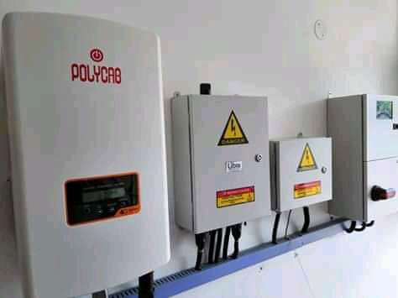 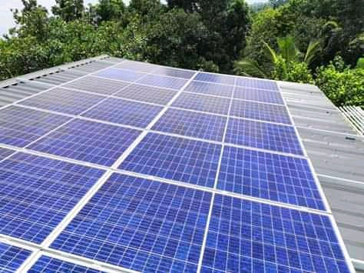

**House wiring**

We do house electrical installations (circuit design, decking, tubing and wiring) for all houses ranging from low, medium and cost. Quality workmanship is our priority and our designs are modern and up to date with current trends. We are specialists in home improvements, DB upgrades, fittings upgrades and house re-wiring.

 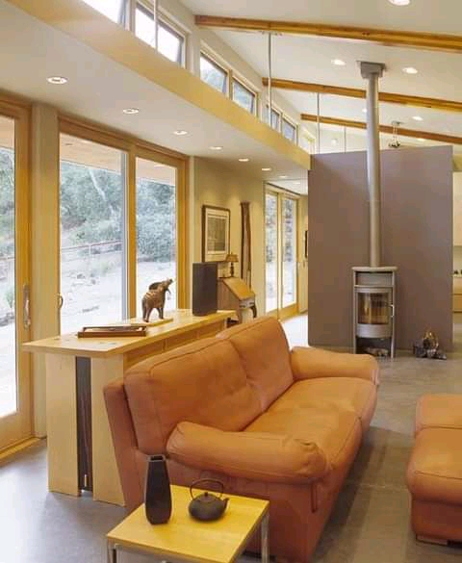

**General repairs and maintenance**

Brilliant Engineering is also involved in the installation, repairs and maintenance of domestic equipment and machines including but not limited to cookers, ovens, laundry machines, electric gates, electric fence installations and repairs, geysers, borehole pumps installations and repairs, swimming pool pumps installations and repairs, microwave repairs, inverter repairs.

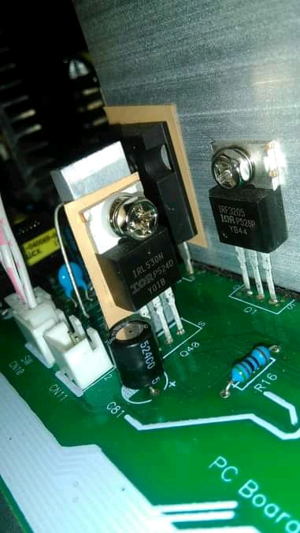 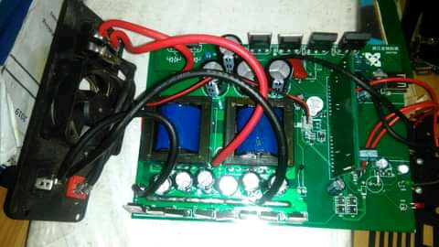

**Generator maintenance and installations**

Every business needs a power back up system; others go for solar systems while others prefer a standby generator. For all your generator installations, services and maintenance, Brilliant Engineering is the right team for the job. We do generator installations ranging from small domestic sets to large commercial generators.

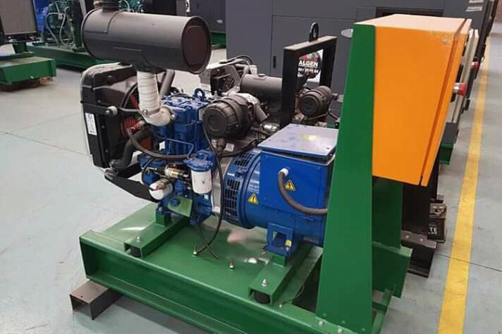

GENERATOR

**Hardware supplies**

We supply Electrical and mechanical equipment spares; MCBs, contactors, relays, heating elements, cables, insulation tape, bearings, oil seals, oils, sensors, light fittings, switches, push buttons, timers and many more.

